Nama Kelompok :

1. Javen Jonathan
2. Farhan Abie Ardandy
3. Muhammad Abubakar Rizvi
4. Rahmatul Fajri

Kelas : Khasanah Ilmi

**TUGAS RL: Q-Learning Implementation**

* Terdapat 3 file dan 1 folder image, 3 file tersebut adalah agent_brain.py berisikan tentang algoritma QL, env.py berisikan tentang cara membuat environment yang mengambil input gambar dari folder image, dan run_agent.py yang berisikan untuk running agent.
* Untuk menjalankan program, tinggal jalankan run_agent.py saja.
* **Tugas:** merubah tata letak environment yang sudah ada, mulai daro posisi robot, posisi goal yang dituju, dan tata letak obstacle. Rubah di bagian env.py

Code in Drive link:

<https://ptorbitventurainodnesiamy.sharepoint.com/:f:/g/personal/ryan_orbitfutureacademy_sch_id/EvGMVJnTVY1FnBzGvWwY4SIBd30m1LhJ36Jk3Ychbl3Qow?e=nYEFav>

Tampilan awal run_agent.py (sebelum diubah):

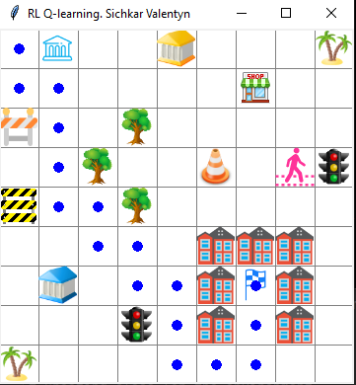

Grafik yang didapatkan:

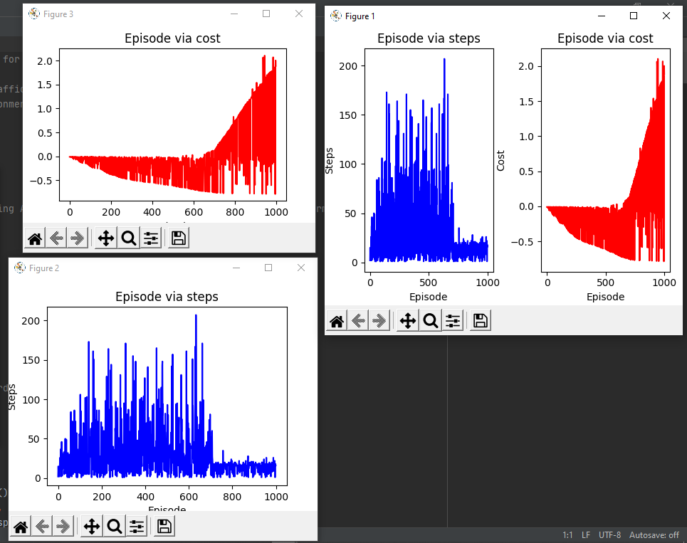

Tampilan run_agent.py setelah diubah:

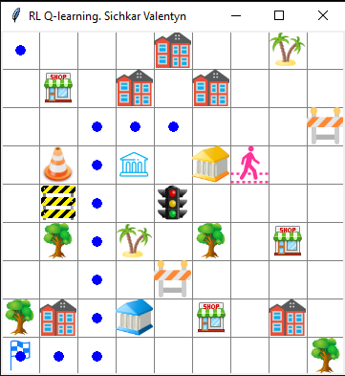

Grafik yang didapatkan:

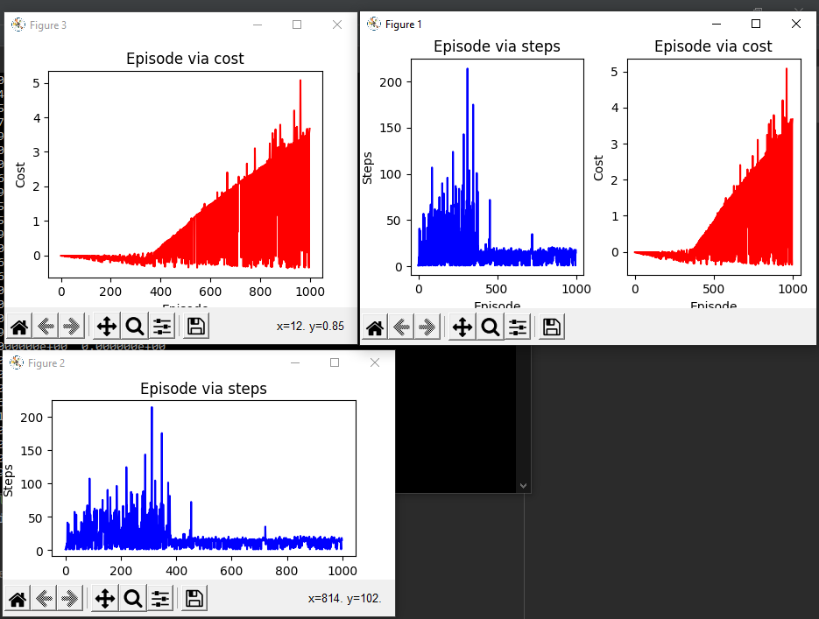

**Perubahan:**

* Penempatan final point diubah ke posisi (pixels * 1, pixels * 7)
* Penempatan agent diubah ke posisi (pixels * 7, pixels * 1)
* Penempatan beberapa obstacle dirubah sedemikian rupa agar seperti pada gambar diatas.

Program:

# File: env.py

# Description: Building the environment-1 for the Mobile Robot to explore

# Agent - Mobile Robot

# Obstacles - 'road closed', 'trees', 'traffic lights', 'buildings'

# Environment: PyCharm and Anaconda environment

#

# MIT License

# Copyright (c) 2018 Valentyn N Sichkar

# github.com/sichkar-valentyn

#

# Reference to:

# Valentyn N Sichkar. Reinforcement Learning Algorithms for global path planning // GitHub platform. DOI: 10.5281/zenodo.1317899

# Importing libraries

import numpy as np # To deal with data in form of matrices

import tkinter as tk # To build GUI

import time # Time is needed to slow down the agent and to see how he runs

from PIL import Image, ImageTk # For adding images into the canvas widget

# Setting the sizes for the environment

pixels = 40 # pixels

env_height = 9 # grid height

env_width = 9 # grid width

# Global variable for dictionary with coordinates for the final route

a = {}

# Creating class for the environment

class Environment(tk.Tk, object):

def __init__(self):

super(Environment, self).__init__()

self.action_space = ['up', 'down', 'left', 'right']

self.n_actions = len(self.action_space)

self.title('RL Q-learning. Sichkar Valentyn')

self.geometry('{0}x{1}'.format(env_height * pixels, env_height * pixels))

self.build_environment()

# Dictionaries to draw the final route

self.d = {}

self.f = {}

# Key for the dictionaries

self.i = 0

# Writing the final dictionary first time

self.c = True

# Showing the steps for longest found route

self.longest = 0

# Showing the steps for the shortest route

self.shortest = 0

# Function to build the environment

def build_environment(self):

self.canvas_widget = tk.Canvas(self, bg='white',

height=env_height * pixels,

width=env_width * pixels)

# Uploading an image for background

#img_background = Image.open("images/bg.png")

#self.background = ImageTk.PhotoImage(img_background)

# # Creating background on the widget

#self.bg = self.canvas_widget.create_image(0, 0, anchor='nw', image=self.background)

# Creating grid lines

for column in range(0, env_width * pixels, pixels):

x0, y0, x1, y1 = column, 0, column, env_height * pixels

self.canvas_widget.create_line(x0, y0, x1, y1, fill='grey')

for row in range(0, env_height * pixels, pixels):

x0, y0, x1, y1 = 0, row, env_height * pixels, row

self.canvas_widget.create_line(x0, y0, x1, y1, fill='grey')

# Creating objects of Obstacles

# Obstacle type 1 - road closed1

img_obstacle1 = Image.open("images/road_closed1.png")

self.obstacle1_object = ImageTk.PhotoImage(img_obstacle1)

# Obstacle type 2 - tree1

img_obstacle2 = Image.open("images/tree1.png")

self.obstacle2_object = ImageTk.PhotoImage(img_obstacle2)

# Obstacle type 3 - tree2

img_obstacle3 = Image.open("images/tree2.png")

self.obstacle3_object = ImageTk.PhotoImage(img_obstacle3)

# Obstacle type 4 - building1

img_obstacle4 = Image.open("images/building1.png")

self.obstacle4_object = ImageTk.PhotoImage(img_obstacle4)

# Obstacle type 5 - building2

img_obstacle5 = Image.open("images/building2.png")

self.obstacle5_object = ImageTk.PhotoImage(img_obstacle5)

# Obstacle type 6 - road closed2

img_obstacle6 = Image.open("images/road_closed2.png")

self.obstacle6_object = ImageTk.PhotoImage(img_obstacle6)

# Obstacle type 7 - road closed3

img_obstacle7 = Image.open("images/road_closed3.png")

self.obstacle7_object = ImageTk.PhotoImage(img_obstacle7)

# Obstacle type 8 - traffic lights

img_obstacle8 = Image.open("images/traffic_lights.png")

self.obstacle8_object = ImageTk.PhotoImage(img_obstacle8)

# Obstacle type 9 - pedestrian

img_obstacle9 = Image.open("images/pedestrian.png")

self.obstacle9_object = ImageTk.PhotoImage(img_obstacle9)

# Obstacle type 10 - shop

img_obstacle10 = Image.open("images/shop.png")

self.obstacle10_object = ImageTk.PhotoImage(img_obstacle10)

# Obstacle type 11 - bank1

img_obstacle11 = Image.open("images/bank1.png")

self.obstacle11_object = ImageTk.PhotoImage(img_obstacle11)

# Obstacle type 12 - bank2

img_obstacle12 = Image.open("images/bank2.png")

self.obstacle12_object = ImageTk.PhotoImage(img_obstacle12)

# Creating obstacles themselves

# Obstacles from 1 to 22

self.obstacle1 = self.canvas_widget.create_image(pixels * 7, pixels * 0, anchor='nw', image=self.obstacle2_object)

# Obstacle 2

self.obstacle2 = self.canvas_widget.create_image(0, pixels * 2, anchor='nw', image=self.obstacle6_object)

# Obstacle 3

self.obstacle3 = self.canvas_widget.create_image(pixels, 0, anchor='nw', image=self.obstacle5_object)

# Obstacle 4

self.obstacle4 = self.canvas_widget.create_image(pixels * 3, pixels * 1, anchor='nw', image=self.obstacle2_object)

# Obstacle 5

self.obstacle5 = self.canvas_widget.create_image(pixels * 1, pixels * 4, anchor='nw', image=self.obstacle12_object)

# Obstacle 6

self.obstacle6 = self.canvas_widget.create_image(pixels * 8, pixels * 8, anchor='nw', image=self.obstacle7_object)

# Obstacle 7

self.obstacle7 = self.canvas_widget.create_image(pixels * 7, pixels * 3, anchor='nw', image=self.obstacle9_object)

# Obstacle 8

self.obstacle8 = self.canvas_widget.create_image(pixels * 6, pixels, anchor='nw', image=self.obstacle10_object)

# Obstacle 9

self.obstacle9 = self.canvas_widget.create_image(pixels * 5, pixels * 5, anchor='nw', image=self.obstacle4_object)

# Obstacle 10

self.obstacle10 = self.canvas_widget.create_image(pixels * 3, pixels * 5, anchor='nw', image=self.obstacle4_object)

# Obstacle 11

self.obstacle11 = self.canvas_widget.create_image(pixels * 5, pixels * 3, anchor='nw', image=self.obstacle4_object)

# Obstacle 12

self.obstacle12 = self.canvas_widget.create_image(pixels * 5, pixels * 7, anchor='nw', image=self.obstacle4_object)

# Obstacle 13

self.obstacle13 = self.canvas_widget.create_image(0, pixels * 8, anchor='nw', image=self.obstacle3_object)

# Obstacle 14

self.obstacle14 = self.canvas_widget.create_image(pixels * 7, pixels * 6, anchor='nw', image=self.obstacle8_object)

# Obstacle 15

self.obstacle15 = self.canvas_widget.create_image(0, pixels * 4, anchor='nw', image=self.obstacle1_object)

# Obstacle 16

self.obstacle16 = self.canvas_widget.create_image(pixels * 8, pixels * 1, anchor='nw', image=self.obstacle3_object)

# Obstacle 17

self.obstacle17 = self.canvas_widget.create_image(pixels * 3, pixels * 3, anchor='nw', image=self.obstacle4_object)

# Obstacle 18

self.obstacle18 = self.canvas_widget.create_image(pixels, pixels * 6, anchor='nw', image=self.obstacle11_object)

# Obstacle 19

self.obstacle19 = self.canvas_widget.create_image(pixels * 4, pixels * 4, anchor='nw', image=self.obstacle8_object)

# Obstacle 20

self.obstacle20 = self.canvas_widget.create_image(pixels * 3, pixels * 7, anchor='nw', image=self.obstacle4_object)

# Obstacle 21

self.obstacle21 = self.canvas_widget.create_image(pixels * 7, pixels * 5, anchor='nw', image=self.obstacle4_object)

# Obstacle 22

self.obstacle22 = self.canvas_widget.create_image(pixels * 7, pixels * 7, anchor='nw', image=self.obstacle2_object)

# Final Point

img_flag = Image.open("images/flag.png")

self.flag_object = ImageTk.PhotoImage(img_flag)

self.flag = self.canvas_widget.create_image(pixels * 1, pixels * 7, anchor='nw', image=self.flag_object)

# Uploading the image of Mobile Robot

img_robot = Image.open("images/agent1.png")

self.robot = ImageTk.PhotoImage(img_robot)

# Creating an agent with photo of Mobile Robot

self.agent = self.canvas_widget.create_image(pixels * 7, pixels * 1, anchor='nw', image=self.robot)

# Packing everything

self.canvas_widget.pack()

# Function to reset the environment and start new Episode

def reset(self):

self.update()

#time.sleep(0.1)

# Updating agent

self.canvas_widget.delete(self.agent)

self.agent = self.canvas_widget.create_image(pixels * 7, pixels * 1, anchor='nw', image=self.robot)

# # Clearing the dictionary and the i

self.d = {}

self.i = 0

# Return observation

return self.canvas_widget.coords(self.agent)

# Function to get the next observation and reward by doing next step

def step(self, action):

# Current state of the agent

state = self.canvas_widget.coords(self.agent)

base_action = np.array([0, 0])

# Updating next state according to the action

# Action 'up'

if action == 0:

if state[1] >= pixels:

base_action[1] -= pixels

# Action 'down'

elif action == 1:

if state[1] < (env_height - 1) * pixels:

base_action[1] += pixels

# Action right

elif action == 2:

if state[0] < (env_width - 1) * pixels:

base_action[0] += pixels

# Action left

elif action == 3:

if state[0] >= pixels:

base_action[0] -= pixels

# Moving the agent according to the action

self.canvas_widget.move(self.agent, base_action[0], base_action[1])

# Writing in the dictionary coordinates of found route

self.d[self.i] = self.canvas_widget.coords(self.agent)

# Updating next state

next_state = self.d[self.i]

# Updating key for the dictionary

self.i += 1

# Calculating the reward for the agent

if next_state == self.canvas_widget.coords(self.flag):

reward = 1

done = True

next_state = 'goal'

# Filling the dictionary first time

if self.c == True:

for j in range(len(self.d)):

self.f[j] = self.d[j]

self.c = False

self.longest = len(self.d)

self.shortest = len(self.d)

# Checking if the currently found route is shorter

if len(self.d) < len(self.f):

# Saving the number of steps for the shortest route

self.shortest = len(self.d)

# Clearing the dictionary for the final route

self.f = {}

# Reassigning the dictionary

for j in range(len(self.d)):

self.f[j] = self.d[j]

# Saving the number of steps for the longest route

if len(self.d) > self.longest:

self.longest = len(self.d)

elif next_state in [self.canvas_widget.coords(self.obstacle1),

self.canvas_widget.coords(self.obstacle2),

self.canvas_widget.coords(self.obstacle3),

self.canvas_widget.coords(self.obstacle4),

self.canvas_widget.coords(self.obstacle5),

self.canvas_widget.coords(self.obstacle6),

self.canvas_widget.coords(self.obstacle7),

self.canvas_widget.coords(self.obstacle8),

self.canvas_widget.coords(self.obstacle9),

self.canvas_widget.coords(self.obstacle10),

self.canvas_widget.coords(self.obstacle11),

self.canvas_widget.coords(self.obstacle12),

self.canvas_widget.coords(self.obstacle13),

self.canvas_widget.coords(self.obstacle14),

self.canvas_widget.coords(self.obstacle15),

self.canvas_widget.coords(self.obstacle16),

self.canvas_widget.coords(self.obstacle17),

self.canvas_widget.coords(self.obstacle18),

self.canvas_widget.coords(self.obstacle19),

self.canvas_widget.coords(self.obstacle20),

self.canvas_widget.coords(self.obstacle21),

self.canvas_widget.coords(self.obstacle22)]:

reward = -1

done = True

next_state = 'obstacle'

# Clearing the dictionary and the i

self.d = {}

self.i = 0

else:

reward = 0

done = False

return next_state, reward, done

# Function to refresh the environment

def render(self):

#time.sleep(0.03)

self.update()

# Function to show the found route

def final(self):

# Deleting the agent at the end

self.canvas_widget.delete(self.agent)

# Showing the number of steps

print('The shortest route:', self.shortest)

print('The longest route:', self.longest)

# Creating initial point

origin = np.array([20, 20])

self.initial_point = self.canvas_widget.create_oval(

origin[0] - 5, origin[1] - 5,

origin[0] + 5, origin[1] + 5,

fill='blue', outline='blue')

# Filling the route

for j in range(len(self.f)):

# Showing the coordinates of the final route

print(self.f[j])

self.track = self.canvas_widget.create_oval(

self.f[j][0] + origin[0] - 5, self.f[j][1] + origin[0] - 5,

self.f[j][0] + origin[0] + 5, self.f[j][1] + origin[0] + 5,

fill='blue', outline='blue')

# Writing the final route in the global variable a

a[j] = self.f[j]

# Returning the final dictionary with route coordinates

# Then it will be used in agent_brain.py

def final_states():

return a

# This we need to debug the environment

# If we want to run and see the environment without running full algorithm

if __name__ == '__main__':

env = Environment()

env.mainloop()